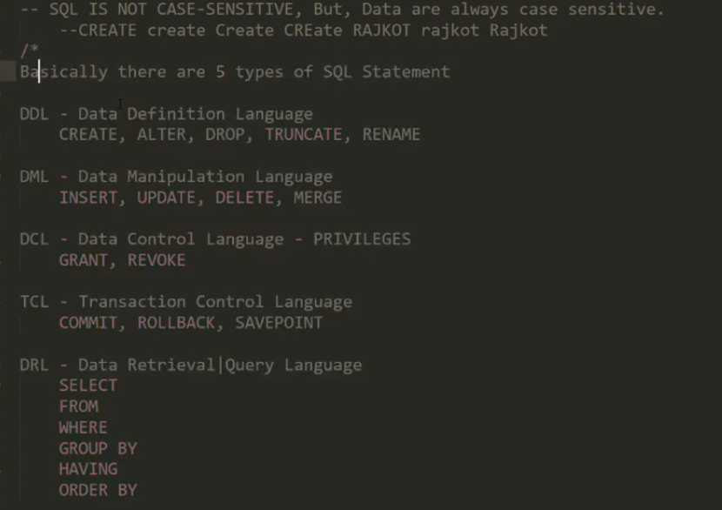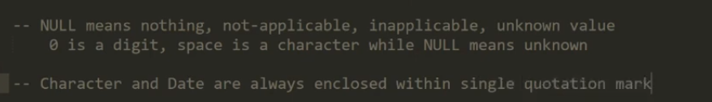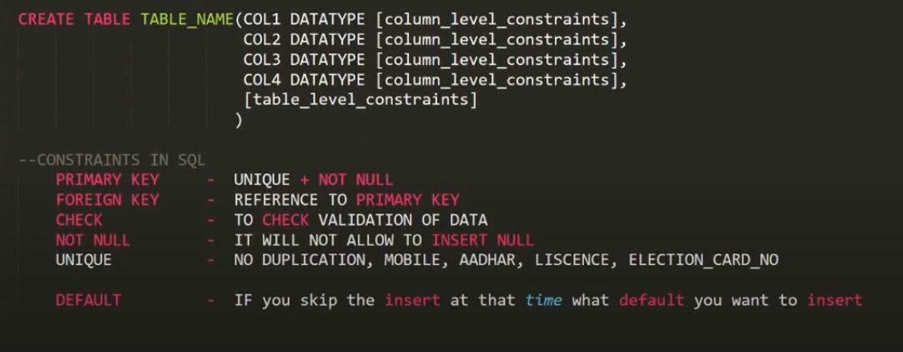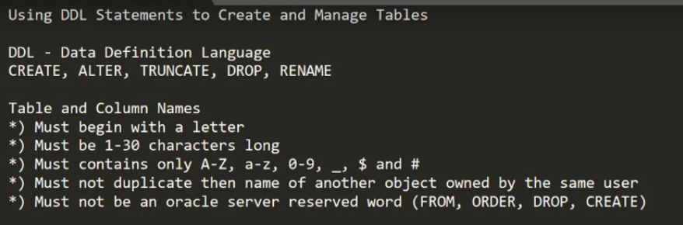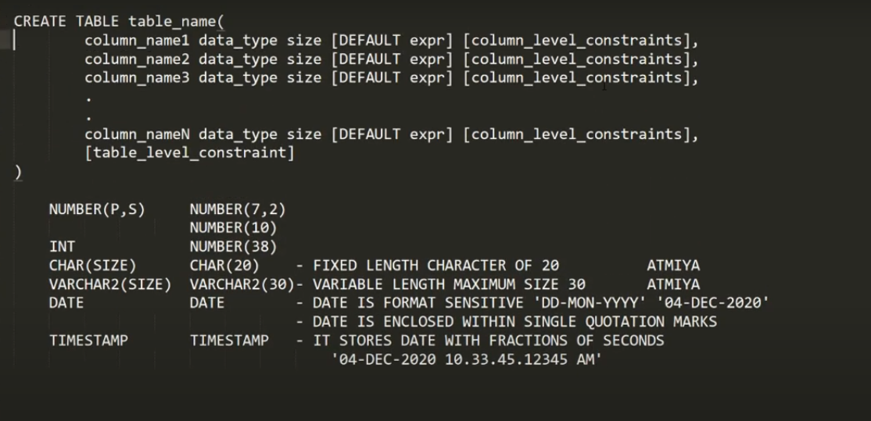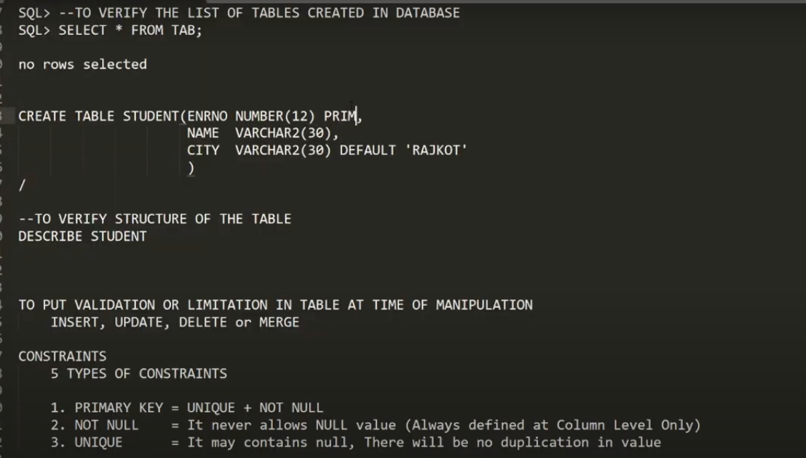

Creation of Table with constrainsts

CREATE TABLE Student( ROLLNO NUMBER(10) PRIMARY KEY ,

NAME VARCHAR(30) NOT NULL,

CITY VARCHAR (30) DEFAULT ‘RAJKOT’,

MOBILE NUMBER(10) UNIQUE CHECK(LENGTH(MOBILE) = 10)

)

